Setting Up Project Permissions

By Jason Agron

The purpose of this tutorial is to teach how to setup XPS project permissions to work correctly under the EECS Linux/Windows File System. This involves a simple process of setting the correct file permissions of the XPS directory under Linux.

To begin, launch the SSH (Secure Shell Client) from the Windows “Start” menu which is located under the “SSH Secure Shell” heading.

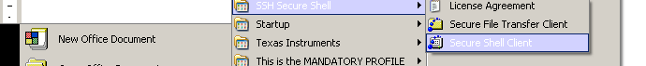

Once, the SSH program starts, click on “Quick Connect”. This will open up a login to the EECS computer system (eno.eecs.ku.edu). You must use your EECS username and password to logon to the system.

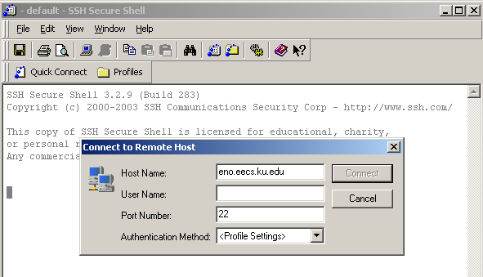

Once, logged in you must go to your 388 directory up until the directory that contains your XPS project (changing directories can be done with the cd command). From here type the following command.

chmod 777 <your_XPS_directory_name>

This changes the permissions of this folder and all of its contents to the proper settings. Now you can successfully launch the XPS and use the built-in Wizards to create IP cores.

