Adding Memory To the OPB Bus

By Jason Agron & Fabrice Baijot

This document describes how to add a bank of Block RAM (BRAM) to the On-Chip Peripheral Bus (OPB) within EDK/XPS. Block RAM comes in the form of 512 x 32-bit blocks of SRAM cells embedded within the Virtex-II Pro FPGA. It has very fast access time (approx. 1 clock cycle for writes, and 2 clock cycles for reads).

The basic steps in adding BRAM to the OPB are:

- Add an OPB BRAM controller.
  - This controller has 2 port connections:
    - OPB bus connection
    - Memory connection (PORT A).
- Add a BRAM memory block to the system.
  - This IP core has 2 port connections:
    - Memory Port A.
    - Memory Port B.
- Connect the OPB BRAM controller to the OPB bus.
  - Connect the OPB bus connection to the OPB bus.
- Connect the OPB BRAM controller to the BRAM memory block.
  - Connect the controller’s memory connection to one of the ports on the BRAM block (either PORT A or PORT B).
- Set the memory size and base address for the BRAM controller.
  - This effectively sets the memory range automatically.

To begin, open up an existing EDK project. Next, go to the IP catalog tab and expand the options for “Memory Controller”. Select the “OPB BRAM Controller”, now right-click and select “Add IP” to add this piece of IP to your system.

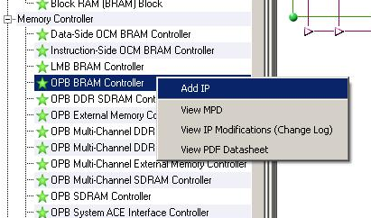

Next, expand the options for “Memory Block”. Select the “Block RAM (BRAM) Block”, now right-click and select “Add IP” to add this piece of IP to your system.

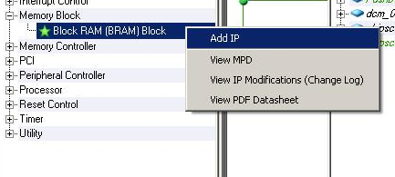

Now, the 2 memory components (memory block and memory controller) have been added to the system. This can be verified by looking at the “Bus Interface” version of the “System Assembly View” in the top-right quadrant of XPS. The 2 components should be at the bottom of the view and look something like the figure below:

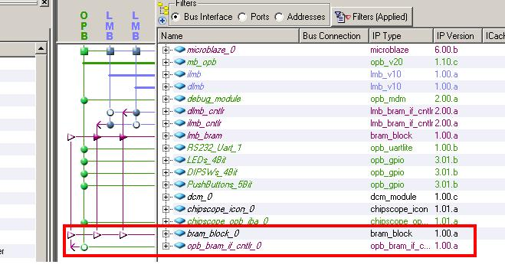

Now, the next step is to hook up the components. First, expand the options for the “opb_bram_if_cntlr”. There should be an empty green circle that lines up with the OPB bus in the system. By clicking on this circle, which should make it a solid green circle, you effectively connect the bus connector of the BRAM controller to the bus.

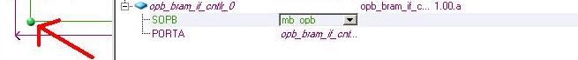
Now, the memory controller is connected to the bus, and now we just need to connect the memory controller to actual memory block. This can be done by first expanding the options for “bram_block_0”. There should be 2 port connections listed: PORT A and PORT B. We must now connect one of the port connections of the BRAM block to the port connection of the BRAM memory controller. This can be done by selecting one of the 2 purple triangles of the BRAM block available on the line extending from the BRAM controller.

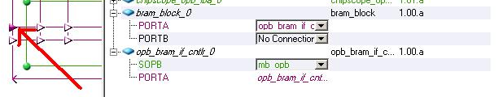

Now the memory block is connected to the memory controller AND the memory controller is hooked to the bus, but there is still one more step. We must set the address range for the BRAM controller. To get started, open up the “Addresses” view of the “System Assembly View”. From this view, one can see that the size specified for the OPB BRAM controller is set to “U” which means unspecified as shown below.

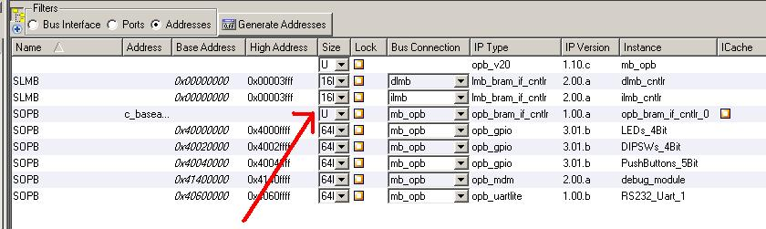

First, let us set the size of the memory to 8K by selecting the size drop down box for the BRAM controller and selecting 8K. Doing so will automatically set the base address and high address for the BRAM controller, however we will change these values ourselves. To do this, first select the base address for the OPB BRAM controller and set the value to 0x50000000. This will automatically update both the base and high addresses with consideration for the size that was selected in the previous step. Now, the BRAM controller should be fully setup as shown below.

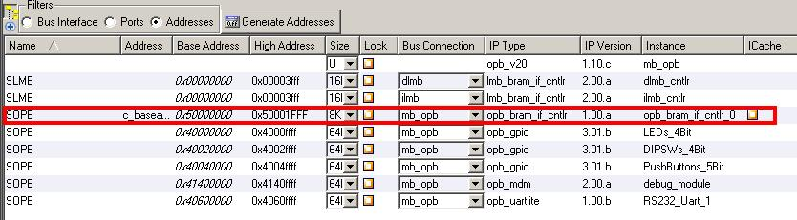

Now, the base system has been augmented with a bank of BRAM memory attached to the OPB bus. In order to use this system we must first re-build the hardware. This can be done by selecting “Device Configuration” and then “Download Bitstream” from the top-level menu of XPS.

